UHF Reader User Manual
- Enter UHF demo by clicking ‘UHF-G’ which is preinstalled in the device;
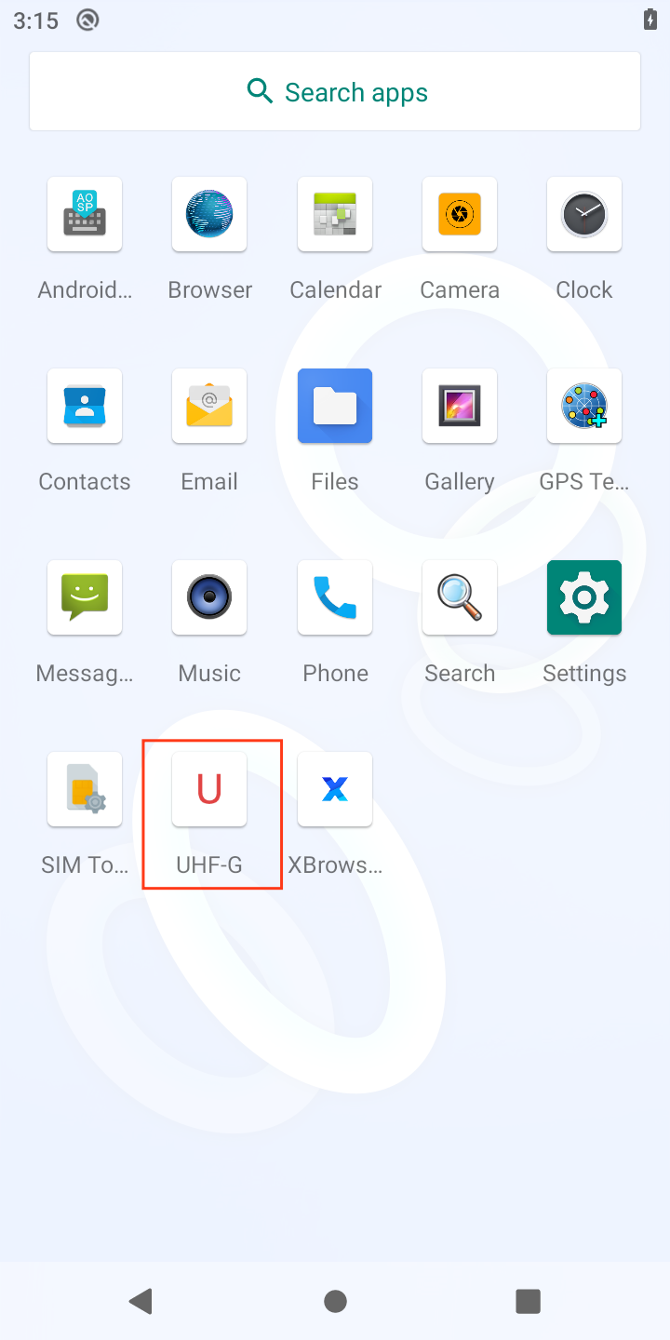
- Click ‘Start’ to start reading UHF tags, EPC data by default, TID data when selecting ‘TID’. For environment of multiple tags, please select ‘Multi Tag’ to increase reading efficiency. ‘Multi tag’ mode would conflict when selecting ’TID’ at the same time;
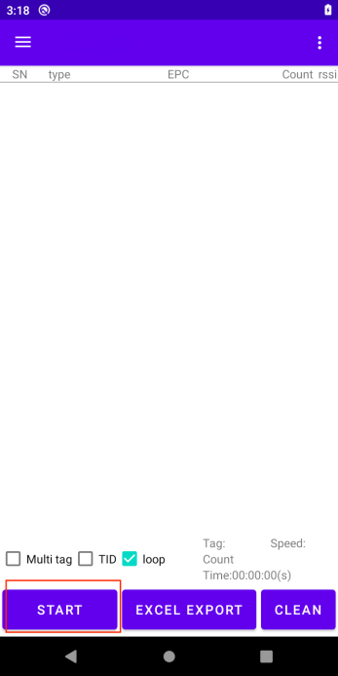
- On the bottom right, items of tag amount/reading speed/time/reading times, EPC by default(reading model switch can only be set when reading is stopped);
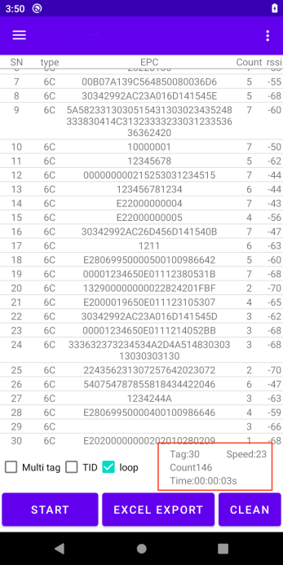
- Click ‘EXCEL EXPORT’ to save EPC with format of XLS file, and showing path as follows:

- Click top left corner or top right corner to pop-up the menu, and click ‘Read Write tag’ to operate EPC which was read;
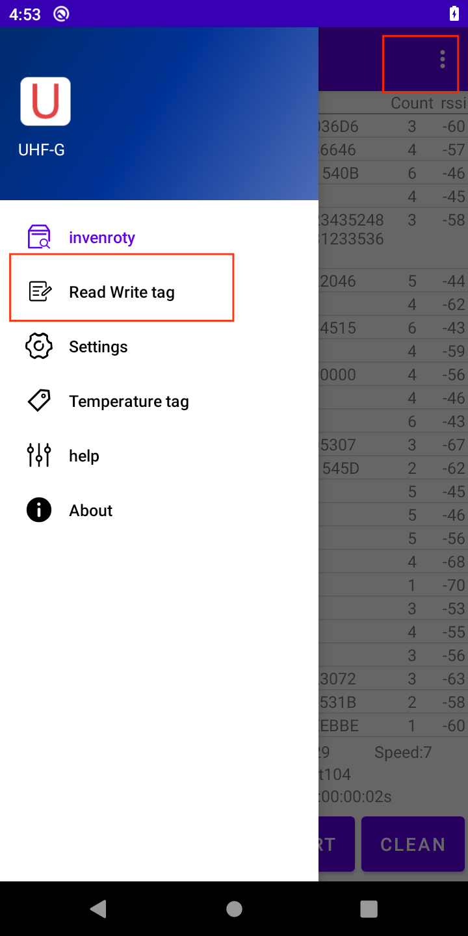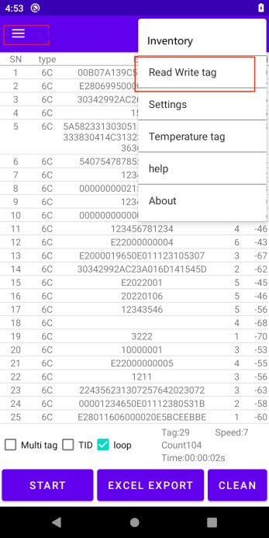
- Select EPC column to get EPC read, and select the proper EPC to operate;
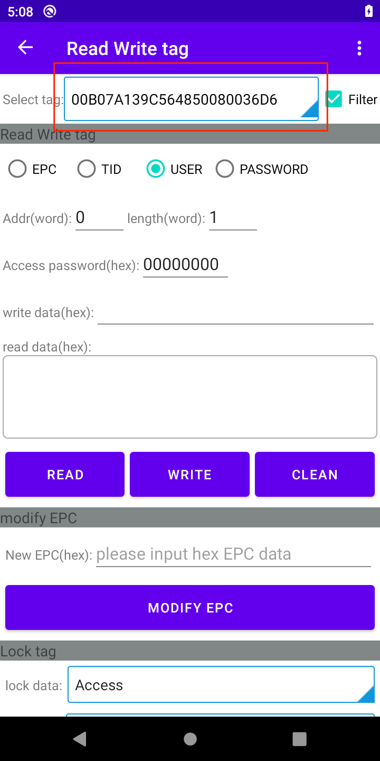
- After selecting EPC, select the following column to operate, then input the correct password(00000000 by default);
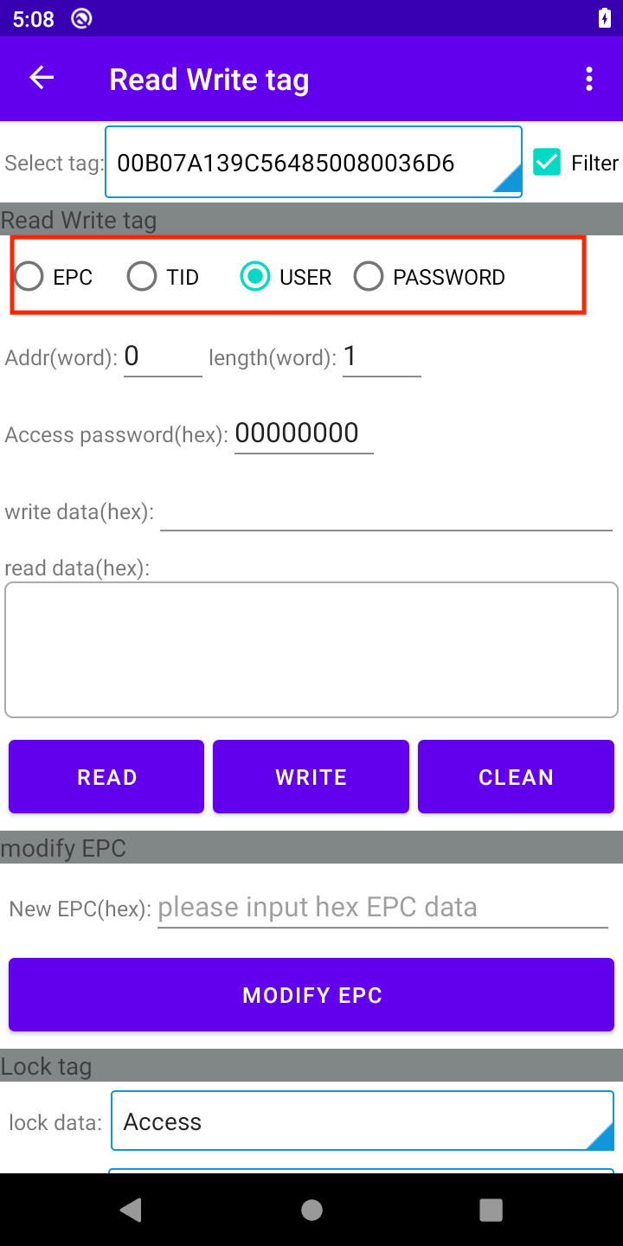
- Click ‘READ’ to read data, and click ‘WRITE’ to write data, message of ‘Success’ would pop up when data is written successfully; Starting address indicates starting position of area to be read/written, length as data length to be read/written, default as 0 and 1;
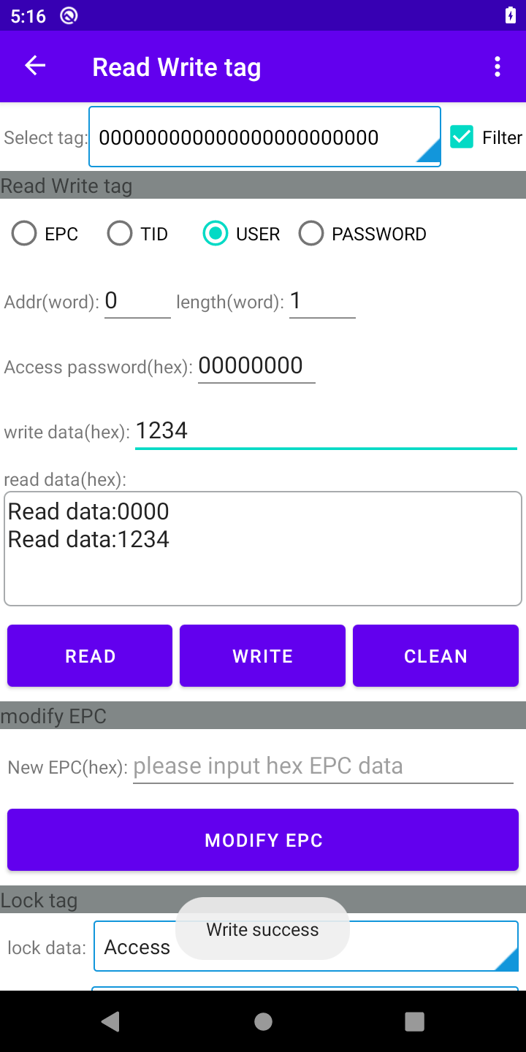
- ‘Modify EPC’ to write new EPC, write new EPC to the column and click ‘Modify EPC’, message of success would pop-up when success;
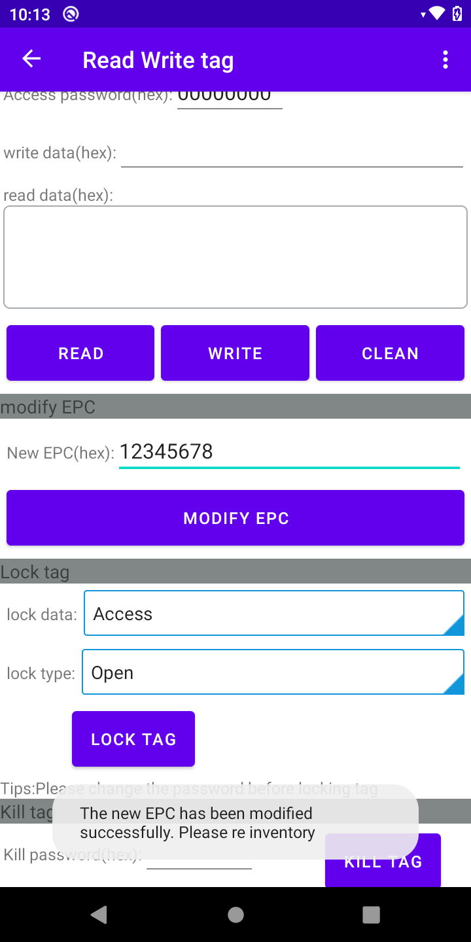
Please re-inventory to read the new EPC after being modified, and carry out the further operations;
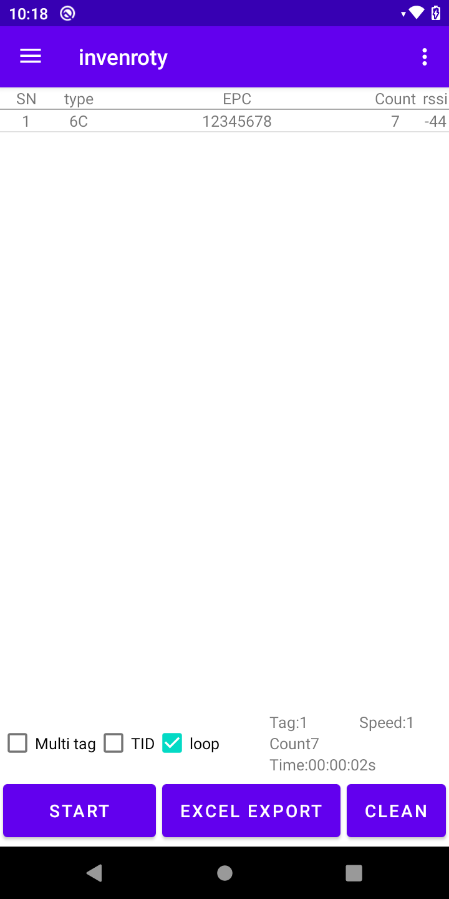
- Click ‘LOCK TAG’ and select different modes based on the requirements;
About LOCK TAG:
Lock status includes 4 modes, and details as two situations:
1）If access password is not modified, and 00000000 by default:
Unlocked: Read/Write can be operated by default password of 00000000;
Temporary lock: Read/Write can be operated by default password of 00000000;
Permanent lock: Read can be operated by default password of 00000000, write cannot be operated;
Unlock: Unlock temporary area to unlocked status, permanent lock area cannot be unlocked;
2）If access password was modified, 000000FF as the example:
Unlocked: Read/Write can be operated by default password of 00000000 or 000000FF;
Temporary lock：RESERVER area can be read/written by password of 000000FF; when other area(except TID) is temporary lock, use password of 00000000 or 000000FF to read, use password of 000000FF to write;
Permanent lock: RESERVER area can be read by password of 000000FF; when other area(except TID) is permanently locked, use password of 00000000 or 000000FF to read
Unlock: Unlock temporary area to unlocked status, permanent lock area cannot be unlocked;
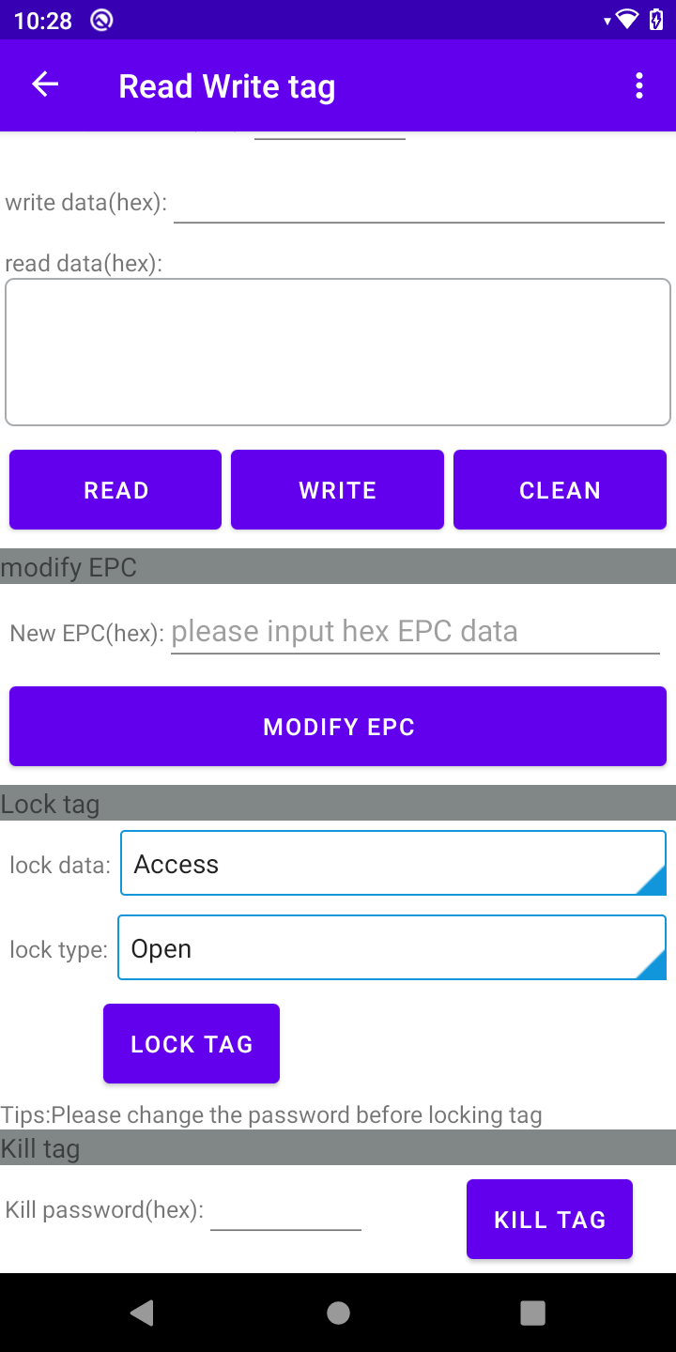
- Output power settings to set output power, ranging from 5 to 33 dBm, 33 dBm by default. Frequency regions includes the following regions:
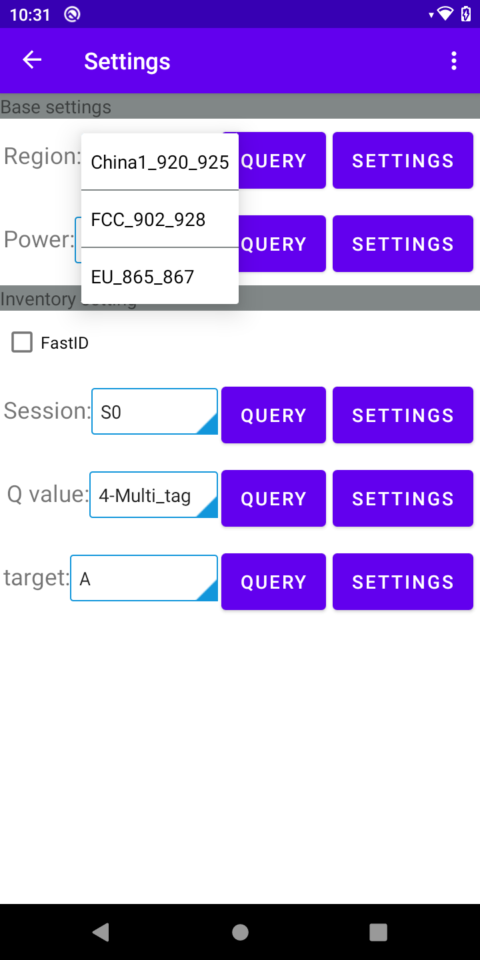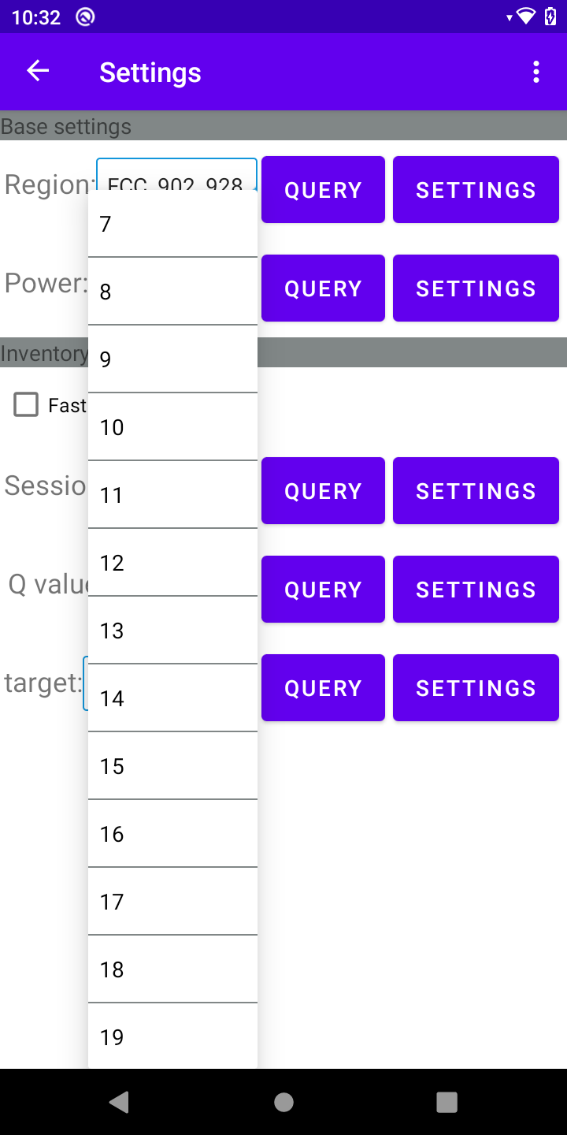
- Technical parameters of uhf reader includes session/Q value/Target, Session of S0, Q value of 4 and Target of A by default.
